IT 327 - Lab #9

ASCII, TTL, RZ, NRZ

# Objective

To gain practice calculating and measuring the bits on ASCII characters with the help of an oscilloscope, and to understand the different line coding methods using TIMS device.

# Procedures

Make sure that your lab could be repeatable by looking at graphs and labels and understandable instructions.

# Step 1

Set up the workstation and become familiar with oscilloscope and terminals, which will send the ASCII values to the scope.

# Step 2

Search on the Internet or another source and find an ASCII table that tells what characters have which binary values. Choose 5 different ASCII values and write down its binary sequence. Write the value down from LSB to MSB.

|  |  |  |  |  |
| --- | --- | --- | --- | --- |
|  | ASCII Character | MSB | LSB | Inverted LSB with Start, Parity and Stop |
| Ex | 1 | 0110001 | 1000110 | 10111001P0 |
| 1 | A | 1000001 | 1000001 | 1011111010 |
| 2 | B | 1000010 | 0100001 | 1101111010 |
| 3 | C | 1000011 | 1100001 | 1001111000 |
| 4 | D | 1000100 | 0010001 | 1110111010 |
| 5 | E | 1000101 | 1010001 | 1010111000 |

# Step 3

Connect the terminal to the oscilloscope (Pins 2 and 7), print the waveform. Identify on the picture, the start, stop, parity, and the bits used to describe the ASCII character. For this section: blue arrows indicate “Start bit”, green arrows indicate “Parity bit”, and orange arrows indicate “Stop bit”.

ASCII character: A, Inverted LSB with Start, Parity and Stop: 1011111010

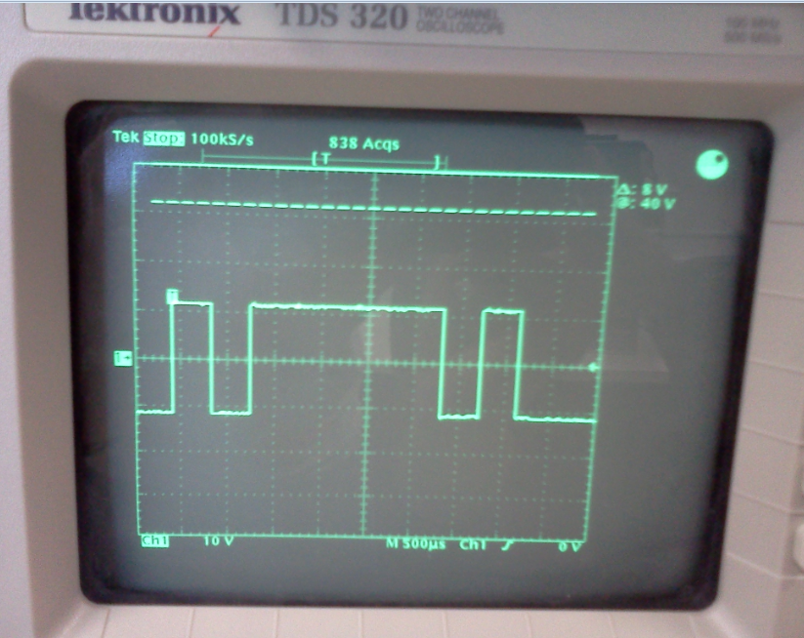

ASCII character: B, Inverted LSB with Start, Parity and Stop: 1101111010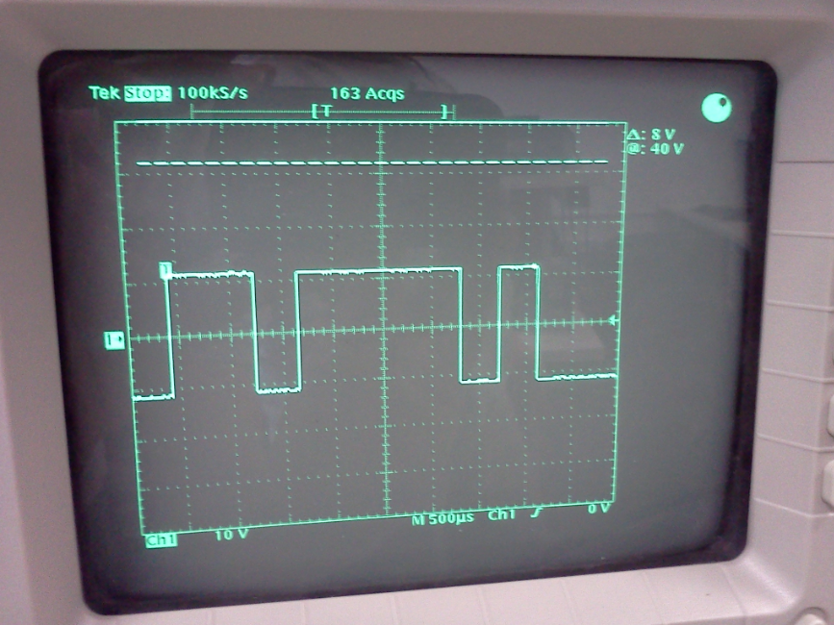

ASCII character: C, Inverted LSB with Start, Parity and Stop: 1001111000

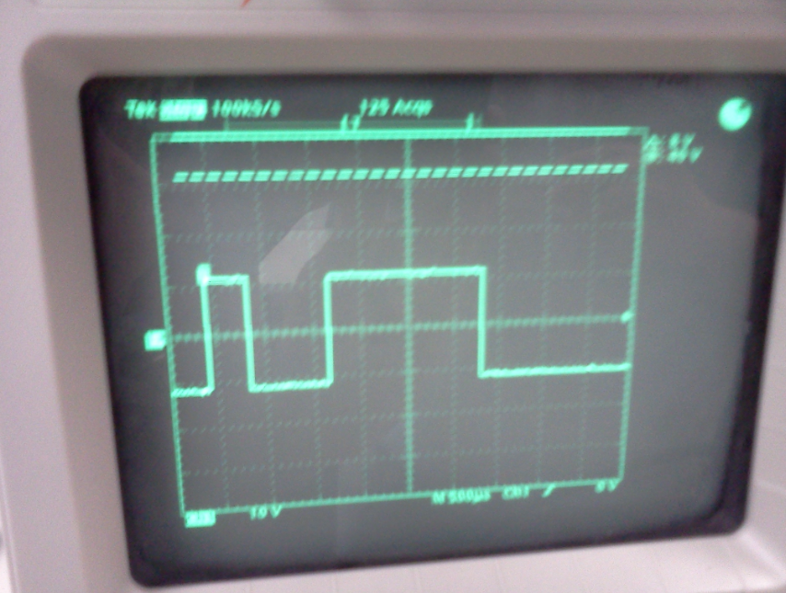

ASCII character: D, Inverted LSB with Start, Parity and Stop: 1110111010

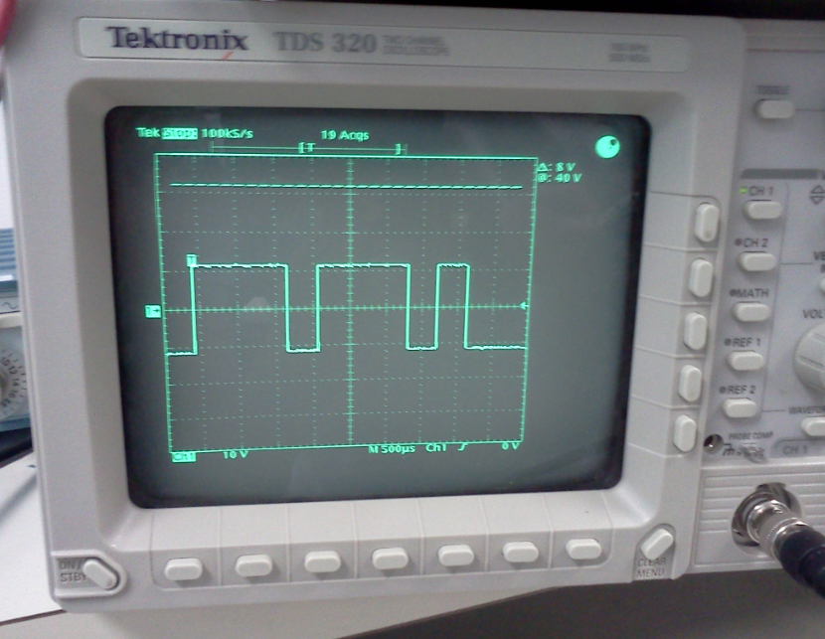

ASCII character: E, Inverted LSB with Start, Parity and Stop: 1010111000

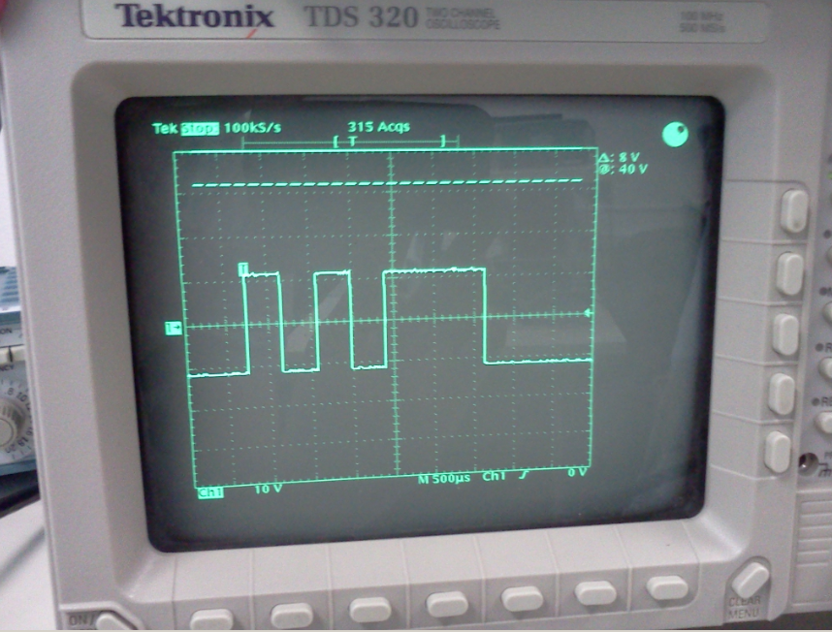

# Step 4

Using TIMS equipment to encode a signal using various methods of encoding.

1. Attach the 8.33kHz sample clock from Master Signals to Master Clock (“M. CLK”) of the Line Encoder.

2. Attach the bit clock (“B. CLK”) of the Line Encoder to the clock of the Sequence Generator.

3. Use the “X” (red) output of the Sequence Generator and connect it to DATA in of the Line Encoder.

4. Connect the Sync of the Sequence Generator to externally trigger the oscilloscope.

5. Hook-up on Ch 1, look at the original bit sequence (Plug into the back of the connection “X” or “DATA”)

6. Connect Ch 2 to the various encoding methods on the Line Encoder such as: NRZ-L, NRZ-M, UNI-RZ, and BIP-RZ and compare it to the sequence on Ch1.

This is a screenshot of TIMS and cables from the instructions above:

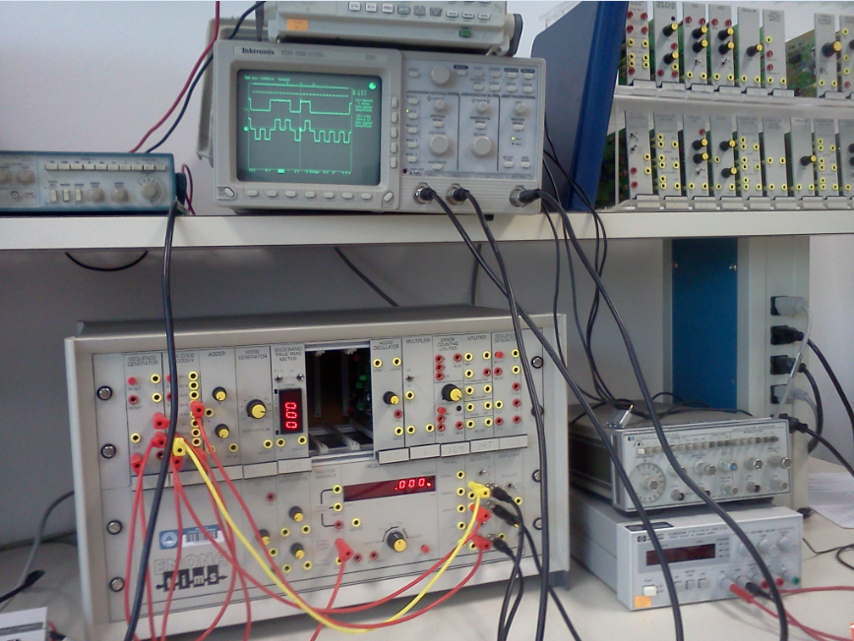

Below are screenshots showing the oscilloscope monitor of the coding methods along with the original signal.

**NRZ-L**: oscilloscope displaying of the coding methods along with your original signal, channel 1 original bit sequence and channel 2 line encoder NRZ-L.

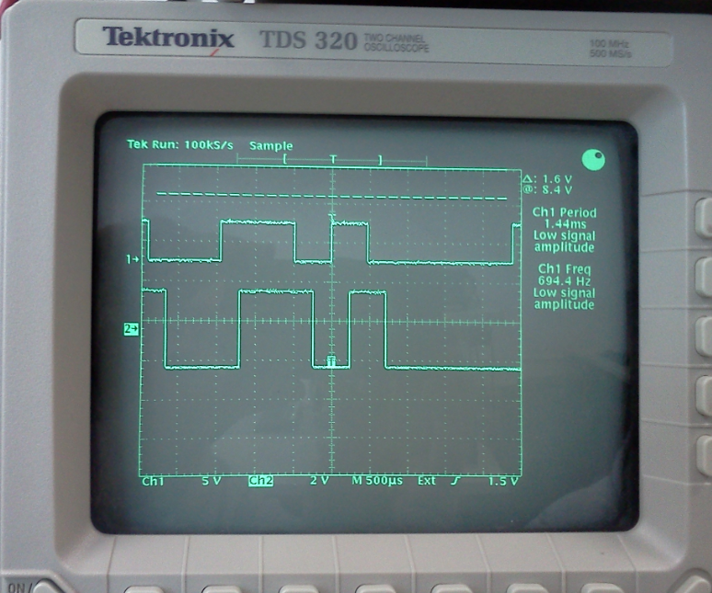

**NRZ-M**: oscilloscope displaying of the coding methods along with your original signal, channel 1 original bit sequence and channel 2 line encoder NRZ-M.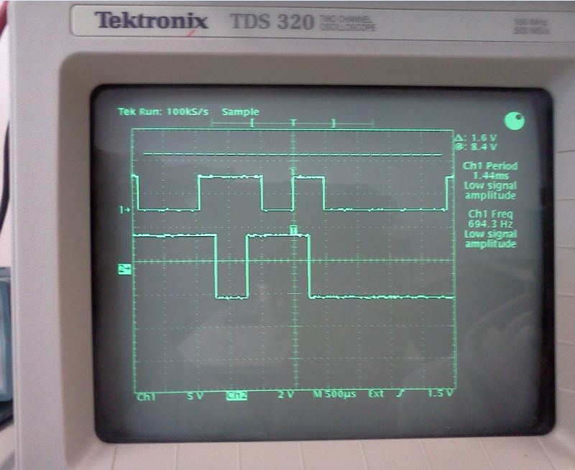

**UNI-RZ**: oscilloscope displaying of the coding methods along with your original signal, channel 1 original bit sequence and channel 2 line encoder UNI-RZ.

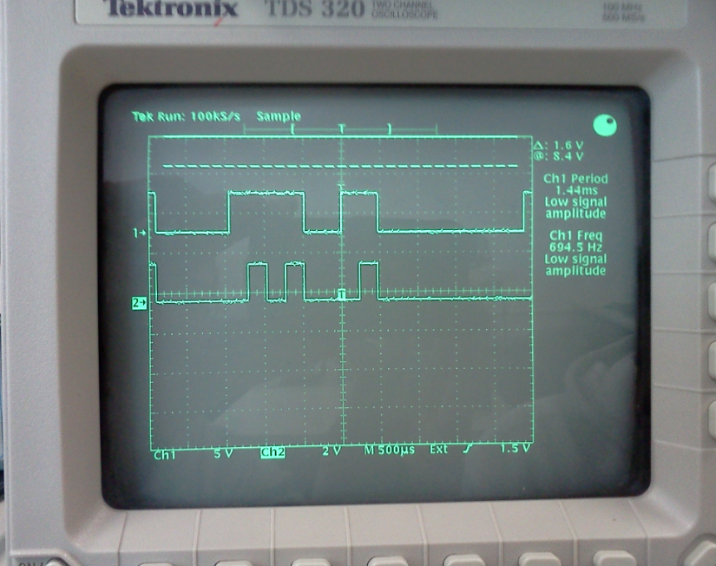

**BIP-RZ**: oscilloscope displaying of the coding methods along with your original signal, channel 1 original bit sequence and channel 2 line encoder BIP-RZ.

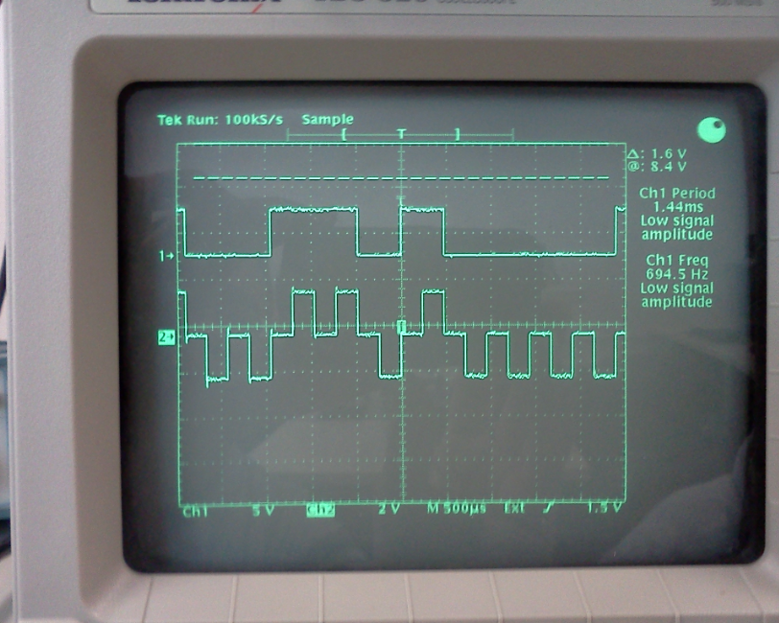

## Questions:

ASCII:

How are the bits different on the oscilloscope different than those that you looked up for each ASCII character?

They are the inverted LSB from the ASCII value with start and stop bits and parity

Is the parity even or odd? How do you know?

Odd parity I knew how to define them with the amounts of 1 found in the bits on the inverted LSB or by looking at the oscilloscope.

What was the Baud Rate (bits/second)?

B =1/T = 1/(830.1 micro seconds) = 1.205 Nano seconds.

TIMS:

What is the pattern for the different line encodings (Hint see pages 44-45 and the chart on 46 in Volume D1 of the TIMS manual, or the pdf link on the Lab website)?

Line encodings:

**NRZ-L**: meaning Non return to zero - level (bipolar): this is a simple scale and level shift of the input TTL waveform.

**NRZ-M**: meaning Non return to zero - mark (bipolar): there is a transition at the beginning of each ‘1’ and no change for a‘0’. The ‘M’ denotes to ‘inversion on mark’. This is a differential code. The decoder gives the correct output independently of the polarity of the given input.

**UNI-RZ**: meaning Uni-polar return to zero (uni-polar): there is a half-width output pulse if the input is a ‘1’; there is no output if the input is a ‘0’. This waveform has a significant DC component in it.

**BIP-RZ**: meaning Bipolar return to zero (3-level): there is a half-width +ve output pulse if the input is a ‘1’; or a half-width -ve output pulse if the input is a ‘0’. There is a return-to-zero for the second half of each bit period.

# Equipment Used

* Emona Tims equipment- Manufacture: Emona Instruments.
* Oscilloscope: Tektronix TDS 320
* Terminal/monitor.

# Report

As I look up on the internet for the ASCII table and its binary values I was able to find an extensive table that contained all values from the ASCII code table.

It is important to know the difference between MSB, which stands for most significant bit, and LSB, which stands for least significant bit. The reason why is because the receiver used in this lab inverts the bits and shows it in LSB format.

To calculate the parity it is a matter of identifying the amount of “1” bit in the sequence of bits, if the number summed is even then parity is 1 as to make the number of “1” bits odd. If number summed is odd then parity is o as to keep the number of “1” bits odd.

Using TIMS in this lab allowed me to see different line encoders that there are available such as NRZ-L, NRZ-M, UNI-RZ, and BIP-RZ. In a digital transmission system line encoding is the final digital processing performed on the signal before it is connected to the analog channel, although there may be simultaneous band limiting and wave shaping, in TIMS the LINE-CODE ENCODER accepts a TTL input (Transistor Transistor Logic) between 0 and 5 volts, and the output level is suitable for transmission via an analog channel (±2 volt peak).

# Conclusion

This lab has reinforced me the importance how to use ASCII table in the sending and receiving messages between machines, which in this case would be a sender and a receiver, communicating with each other with random sequence of bits, but because the bits follows a certain pattern understandable to both the sender and receiver then we achieve the transmission message between machines.

This lab also helps me to know the significance of MSB and LSB and how machines make such as receivers, utilizes sequence of bits, modify them in order to make some sense of it.

I feel that this lab is helpful for my career as I understand how machines code and decode signals, understanding the ASCII table is a must in the IT field when dealing with that low level of job. I feel confident to use devices such as oscilloscope, TIMS and the terminal as to understand the decoded signal, and therefore able to perform tasks that requires understanding of Line coding and ASCII table sequence bit pattern.

# References

**TTL**: http://wiki.answers.com/Q/What_is_a_TTL-compatible_input

**Lab 9**: http://it327.groups.et.byu.net/

**ASCII table**: http://www.tutorialspoint.com/html/ascii_table_lookup.htm

**Line code-encoders**: ftp://ftp.eng.auburn.edu/pub/roppeth/TIMS-Manuals/TIMS%20Experiment%20Manuals/LabSheets/Individual%20LabSheets/L-42.pdf

**Name: Lehi Alcantara**

**Completion Date: 11/01/2011**